TASK 1
You should spend about 20 minutes on this task. Write at least 150 words.
After you finish, use the checklist to evaluate your writing task. Then, compare your task with the sample answer.

The graph below shows the population of India and China from the year 2000 to the present day with projections for growth to the year 2050.
Summarise the information by selecting and reporting the main features, and make comparisons where relevant.
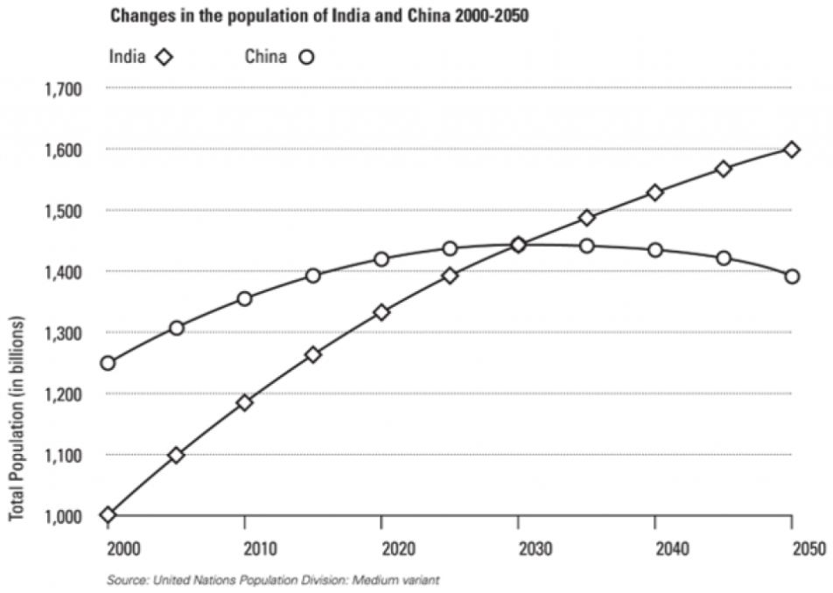

TASK 2
You should spend about 40 minutes on this task. Write at least 250 words
After you finish, use the checklist to evaluate your writing task. Then, compare your task with the sample answer.

Write about the following topic: Many people go through life doing work that they hate or have no talent for. Why does this happen? What are the consequences of this situation?
Give reasons for your answer and include any relevant examples from your own knowledge or experience.

